

**Dunklin R-V School District**

**Strategic Plan**

**2015-2020**

|  |
| --- |
|  |

**Table of Contents**

Background 4

EXECUTIVE SUMMARY 4

Strategic Plan Analysis and Development 9

Internal and External Stakeholder Feedback 9

Organizational Baseline Assessment 9

Key Themes 9

Strengths 9

Opportunities for Improvement 9

Internal Assessment-Focus Group 11

External Assessment-Focus Group 11

Organizational Analysis 11

Dunklin R-V School District Vision, Mission, Core Values, and Core Competencies 11

Vision 11

Mission 12

Core Values 12

Core Competencies 12

Dunklin R-V School Districts’ Current Core Competencies 12

Dunklin R-V School Districts’ Needed Core Competencies 12

Dunklin R-V – Five Year Strategic Advantages and Challenges 13

Strategic Advantages 13

Strategic Challenges 13

Five Year Goals and Objectives 13

Goal One: Student Achievement 13

Goal Two: Stakeholder Engagement 14

Goal Three: Workforce Focus 14

Goal Four: Organizational Sustainability 14

Goal Five: Fiscal Sustainability 14

Balanced Scorecard Development/Strategy Map 16

Evolving the Dashboard and Scorecard 17

Background 17

Balanced Scorecard-Recommended Next Steps 17

Action Plan Development 19

Capacity Analysis 19

Strategic Plan Implementation – Tactical Plan 19

Organizational Performance Review Process 19

Progress on Goals, Objectives, Strategies, and Actions 19

Organizational Performance Scorecard of Progress on Key Performance Indicators 20

Strategic Plan Goals, Objectives and Strategies (2015-2017) 21

Goal Area 1 – Student Achievement 21

Goal Area 2 – Stakeholder Engagement 21

Goal Area 3 – Workforce Focus 21

Goal Area 4 – Organizational Sustainability 21

Goal Area 5 – Fiscal Sustainability 21

Resource Allocation 22

Human Resources 22

Executive Summary

**Dunklin R-V Strategic Plan**

**2015-2020**

# Background

The Dunklin R-V School District has built a reputation as a district of integrity, compassion and growth. Dunklin R-V and its community have a proud heritage and respect for tradition as well as a progressive attitude toward education for all children. The district is committed to providing an innovative education to help our students learn and grow to become tomorrow’s leaders.

Dunklin R-V is nestled along the banks of the Mississippi River and is comprised of the cities of Herculaneum, Pevely, Horine and Southwest Barnhart in Jefferson County Missouri. The district consists of four educational campuses, Pevely Elementary, Senn-Thomas Middle School, Taylor Early Childhood Center, and Herculaneum High School.

The mission statement for the district is to ‘Educate today for a better tomorrow’.

# EXECUTIVE SUMMARY

This strategic plan was developed with a strong focus on transformation of the organization to better support delivery of the current educational services and an aggressive focus on identifying and implementing new approaches to position the Dunklin School District for a strong, sustainable future. This transformation must be supported by a strong internal infrastructure to support growth in new areas.

The Dunklin School District strategic plan is a five year plan developed using the Baldrige framework, a proven, best practices business framework. The strategic planning process was highly inclusive involving Dunklin leadership, employees, students, and partners. The processes used to develop the strategic and tactical portions of the plan have been documented and will be repeated to update the annual tactical plans and the next five year plan in 2020.

The next stage of the process was to develop teams of employees to identify the strategic strategies for focus in the first year of the plan. Over 20 employees and leaders were segmented into teams corresponding with the goal areas identified. The teams each conducted eight meetings to review the information gathered and identified focus areas (strategies) in each respective goal. Detailed plans and resource requirements were identified for each of the strategies, which were then presented to the leadership team for review and prioritization. Those approved will begin implementation in March of 2015. The strategies not approved will be retained for future review and potential re-prioritization. The vision, mission, goals, and objectives identified prior to and during the strategic plan development process will set the direction for the Dunklin School District at a strategic level for the next five years.

An annual update to identify tactical action plans will be developed each year and will be reviewed by the leadership and the Board of Education. A high-level process overview is presented in the management flow graphic following:

Five Year Strategic Plan

-Mission

-Vision

-Goals

-Objectives

**Long-Term Direction Established**

**Dashboard**

**Provides the monthly review of organizational progress against action plans**

**Tactical View of Progress Against**

**Action Plans Established**

**Review and Realignment of Strategic Plan Annually**

**-Leadership Team**

**-Board of Education**

**-Goal Teams**

**-Employees and Departments**

**Annual Review Process**

**One Year Action Plans**

**Tactical plans established each year**

**Implementation** **Plans**

**Plans used to execute action plans and report status throughout the year**

**Strategic Plan Management Flow**

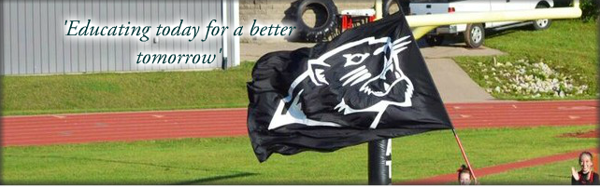

**Dunklin R-V School District**

**Strategic Plan**

**2015-2020**

|  |
| --- |
| **Vision** |

**Dunklin R-V will be a nationally recognized school district**

**that is highly regarded for the achievement and character**

**of our students and the excellence of our people, programs**

**and learning environment.**

|  |
| --- |
| **Mission** |

**‘Educating today for a better tomorrow’**

|  |
| --- |
| **Core Values** |

**Respect**

**Responsibility**

**Integrity**

**Compassion**

**Excellence is expected – Accept the Challenge!**

|  |
| --- |
| **Goals & Objectives** |

**Student Achievement**

* Ensure achievement for all students
* Ensure college and career readiness for all students
* Ensure a healthy, safe, productive learning environment
* Optimize the level of student learning by supporting the needs of a diverse student population

**Stakeholder Engagement**

* Ensure stakeholder satisfaction and engagement
* Ensure effective communication with internal and external stakeholders

**Workforce Focus**

* Ensure employee satisfaction and engagement
* Maintain a capable and highly qualified workforce through effective selection, training, development, and retention

**Organizational Sustainability**

* Utilize technology resources to facilitate student learning and district operations
* Align district work systems and processes with strategic direction supporting a systems focus

**Fiscal Sustainability**

* Ensure financial resources are available to meet strategic and operational needs effectively and efficiently

Strategic Plan Development

# 

# Strategic Plan Analysis and Development

Extensive feedback was gathered during the strategic planning process and was used to develop a plan based on internal and external analysis. The leadership team and teams of employees conducted multiple levels of analysis over the course of several months resulting in the five year strategic plan and the first annual tactical plan. An overview of the information gathered during the development process is provided below.

# Internal and External Stakeholder Feedback

## Organizational Baseline Assessment

Extensive stakeholder feedback was used in the development of this strategic plan. The first type of stakeholder feedback used in the initial stages of this plan’s development was an internal baseline assessment completed by employees using the Baldrige principles, guided by a Baldrige subject matter expert. The assessment was conducted through interviews with senior leadership and employees and identified the organization’s strengths and opportunities for improvement. One area of strength and six opportunities for improvement were identified as key themes providing focus for the development of the plan. The resulting strategic plan addresses all elements identified in the Baldrige criteria for an organizational strategic plan and establishes strategic direction for the next five years and tactical direction for the first year of the plan.

# Key Themes

## Strengths

* **Student-Centered Culture** – A strength identified based on responses by senior leaders and employees (both certified and classified) alike was a consistent focus on serving the students and student achievement. In addition, the District is undertaking several initiatives focused primarily on student achievement, including: Curriculum revision, technology, Network for Educator Effectiveness, transitioning to MSIP 5 standards, and Professional Learning Communities. There is a related opportunity to more actively engage classified employees in the student-centered culture, reinforcing their awareness, as well as linking their roles, responsibilities, and performance to student achievement.

## Opportunities for Improvement

* **Organizational Communication** – There are a substantive number of communication approaches used to communicate with the organization including email, meetings, phone calls, and building visits. An opportunity for improvement could be to address a lack of two-way approaches to communication. The District is in the midst of several important initiatives including curriculum revision, technology, Network for Educator Effectiveness, transitioning to MSIP 5 standards, and Professional Learning Communities, which will require understanding, participation, and support from employees.
* **Strategic Planning** – Historically, the organization has used the Comprehensive School Improvement Plan framework as its primary planning model. It gathered data from a variety of internal and external sources, reviewed results/trends, obtained School Board direction, and cascaded the plan via objectives through several committees and the schools/buildings in the District. However, the current approaches do not include critical Strategic Planning components, for example: current and future Core Competencies, Work Systems, Strategic Advantages, Challenges, and Opportunities, and a concise, long-term Vision Statement. There is evidence of opportunities to pursue a more robust Strategic Planning Process and ensure the entire organization understands the development, deployment, and monitoring of the plan.
* **Organizational Performance Review** – Following the development of a systematic approach to strategic planning that can be used each time strategic planning is conducted, an organizational measurement and review system should be established to ensure review of organizational performance is directly tied to the organization’s strategic plan. While there are several measures for academic achievement, there is an opportunity to align the organization’s measures to fully encompass all areas of the District. Without measures of outcomes of the areas supporting student achievement, an optimum cohesive model is not achieved.
* **Stakeholder Needs Identification –** The district has a variety of methods used to communicate to key internal and external stakeholders, however there are opportunities to improve segmentation, analysis, and correlation of this information. In addition, effectively defining stakeholder engagement could contribute to aligning stakeholder listening methods and developing targeted action to stakeholder engagement. There may be an opportunity to analyze some examples of successful program and initiative implementation (for example, the technology rollout) which can be reviewed to identify how information was gathered, what information was used, and how it correlated to successful outcomes, and to leverage best practices to target future initiatives and contribute to favorable outcomes. Also, the District can take advantage of established collaborative relationships with other school districts to leverage successful methods and approaches. Feedback revealed opportunities to use stakeholder needs to better align curriculum.
* **Workforce Engagement** – Although the District has a very qualified and dedicated workforce, including Certified, Classified, and Administrative personnel, there is no common, measureable definition for workforce engagement. There is evidence, on an anecdotal evidence basis, that the majority of personnel are engaged. However, there is a significant opportunity to better define workforce engagement, thus allowing the organization to develop and align professional development, process management, performance measurement systems, and reward and recognition systems to desired behaviors.
* **Operations Focus –** There are several opportunities to introduce systematic approaches and standardization for program, service and process design, and work processes. A systematic approach for process design may increase the effectiveness of a better aligned curriculum. There was no evidence provided describing how processes were managed or how to implement an idea. There was evidence of inconsistencies between buildings, within buildings, and between Certified and Classified employees. Introducing systematic approaches may allow the organization to validate best practices and leverage them more effectively across the organization.

## Internal Assessment-Focus Group

Focus groups lasted approximately 1.5 hours and featured a mix of qualitative and quantitative questions. The resulting feedback report reflected both types of results presenting information obtained from the focus groups and the key themes identified across the all groups.

Feedback was gathered through conducting focus groups to gather internal and external stakeholder feedback resulting in a detailed focus group report. A Board of Education and Administrators focus group was conducted as a means of determining the leadership input. Both classified and certified staff of Dunklin R-V was included as focus groups to gather workforce input. The internal focus groups were conducted with the following groups:

* Board of Education
* Classified Employees
* Certified Employees

## External Assessment-Focus Group

Feedback was also gathered from external sources with focus groups being conducted with the following external stakeholder groups:

* Dunklin R-V School District enrolled students
* Parents of enrolled students
* Members of the community

A copy of the focus group report is included in the appendix of this document.

# Organizational Analysis

In addition to the information gathered as inputs to the development of the strategic plan, several organizational analyses were conducted to ensure appropriate alignment of the organization’s goals and objectives to the environmental situation. An environmental analysis was conducted that addressed the impacts of the shifts in technology, markets, services provided, stakeholder preferences, competition, the economy, and the regulatory environment. Also, an analysis to address the organization’s sustainability, including current and needed core competencies, was conducted. Finally, an analysis was developed to identify the organization’s strengths, weaknesses, opportunities, and threats (SWOT). The SWOT analysis was then used to identify strategic advantages, challenges, and opportunities.

## Dunklin R-V School District Vision, Mission, Core Values, and Core Competencies

## Vision

Dunklin R-V will be a nationally recognized school district that is highly regarded for the achievement and character of our students and the excellence of our people, programs and learning environment.

## Mission

‘Educating today for a better tomorrow’

## Core Values

Respect

Responsibility

Integrity

Compassion

Excellence is expected – Accept the Challenge!

## Core Competencies

Core competencies are important to review during the strategic planning process as they identification the areas of significant strength for the organization and areas where the organization should be strong in the future.

Current core competencies are defined as the organization’s areas of greatest expertise. The organization’s core competencies are those strategically important capabilities that are central to fulfilling the organization’s mission.

Needed core competencies are areas the organization will need to excel in to be successful in the future. Identifying and addressing an organization’s needed core competencies can support long-term organizational sustainability. The needed core competencies have been addressed in the goals, objectives, and strategies identified in this plan.

### Dunklin R-V School Districts’ Current Core Competencies

* Fiscal responsibility
* Technology resources
* Student-centered culture
* Early childhood program
* Focus on safety
* Student centered – survey attendances , community scholarships

### Dunklin R-V School Districts’ Needed Core Competencies

* Communication among stakeholders
* Accountability in implementation of curriculum
* Attendance rate
* Higher expectations for everyone
* Achievement scores
* Systematic approach to vertical alignment in educating students
* Extensive technology training specific to staff identified needs
* Improved workforce engagement
* Higher achievement through data driven instruction
* Train and retain teachers
* Consistent and meaningful collaboration of staff
* Accountability/consistency of all stakeholders – i.e. grades
* Parent & Community Engagement
* Meeting the needs of the whole child
* Teaching reading
* Systematic approach to all programs/services

# Dunklin R-V – Five Year Strategic Advantages and Challenges

The purpose of the identification of the organization’s strategic advantages and challenges was to serve as a connection between the analysis conducted about the organization during the strategic planning process and the execution of the organization’s goals and objectives. Strategic advantages are those things going well in the organization that should be leveraged as key strengths and tools to execute the goals and objectives. The Strategic Challenges must be overcome as a part of the planning process.

## Strategic Advantages

* Technology Resources
* Financially Responsible
* Student Centered Focus
* Early Childhood Program

## Strategic Challenges

* Lack of Systematic Approach containing training – no approach to assessing programs
* Test Scores – Student Achievement
* Communication District wide
* Mobility/Poverty Rate & more culturally diverse population (student mobility, transient families)(changing demographics)

# Five Year Goals and Objectives

The goals and objectives identified will remain in place for the five year timeframe of the strategic plan. They will be reviewed annually, but unless significant changes occur in the direction of the organization or the industry, they will remain in place for the duration of the plan. Five goal areas were identified.

## Goal One: Student Achievement

Objectives:

* Ensure achievement for all students
* Ensure college and career readiness for all students
* Ensure a healthy, safe, productive learning environment
* Optimize the level of student learning by supporting the needs of a diverse student population

## Goal Two: Stakeholder Engagement

Objectives:

* Ensure stakeholder satisfaction and engagement
* Ensure effective communication with internal and external stakeholders

## Goal Three: Workforce Focus

Objectives:

* Ensure employee satisfaction and engagement
* Maintain a capable and highly qualified workforce through effective selection, training, development, and retention

## Goal Four: Organizational Sustainability

Objectives:

* Utilize technology resources to facilitate student learning and district operations
* Align district work systems and processes with strategic direction supporting a systems focus

## Goal Five: Fiscal Sustainability

Objectives:

* Ensure financial resources are available to meet strategic and operational needs effectively and efficiently

Strategic Measures

# Balanced Scorecard Development/Strategy Map

Parallel to the strategic planning development process, a new Balanced Scorecard strategy map was developed using the theoretical framework of Kaplan and Norton. The goals and objectives were directly aligned with the four Balanced Scorecard perspectives of: Stakeholders, Learning and Growth, Operational, and Financial. The strategy map serves as the basis of the development of the organizational level scorecard that will measure the progress of the organization toward its strategic goals and objectives. The Dunklin School District Strategy Map follows.

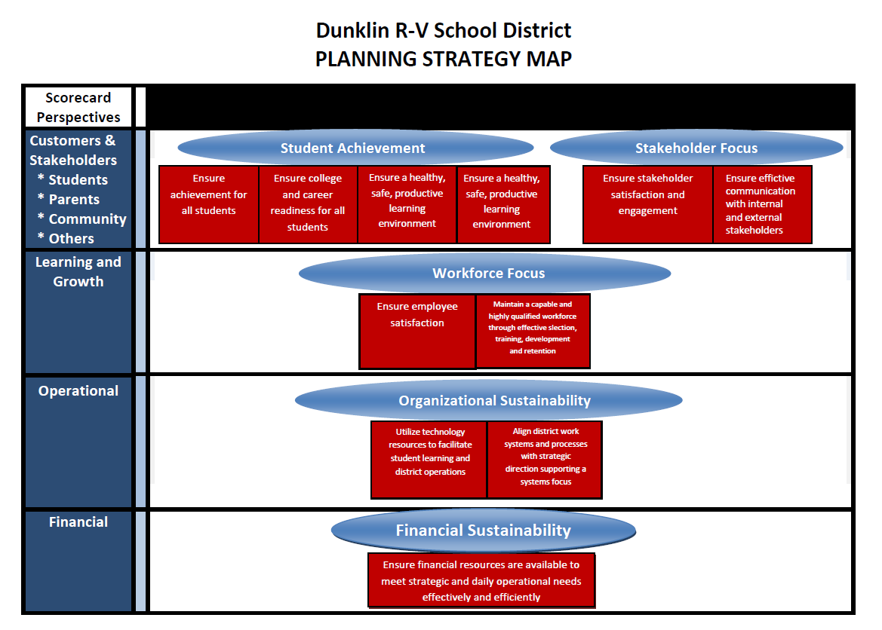

The Balanced Scorecard for the district is still under development and is the next area of focus for the strategic planning process.

# Evolving the Dashboard and Scorecard

## Background

As a part of the strategic planning process, initial measures will be identified for the objectives and strategies which will be reviewed monthly as a part of the leadership review of the progress of the strategic plan. The initial measures identified will be evolved as the plan is deployed and monitored.

Next steps and ongoing review instructions are provided to ensure the continuation of the strategic planning work.

## Balanced Scorecard-Recommended Next Steps

The first year of the strategic plan should feature significant emphasis on the further development of the measures, development of measurement definitions, the data collection plans, identification of comparisons, establishment of targets, and collection of baseline information.

1. **Development of Measures:** First drafts of the recommended measures were identified as a part of the strategic planning process. The scorecard measures should be reviewed in light of other existing measures currently in place to evaluate organizational performance levels. All strategic organizational measures should be integrated into the scorecard.

2. **Development of Measurement Definitions:** Initial definitions will be provided for the measures identified. Review the definitions to ensure that anyone who might be reviewing the scorecard would be able to understand how the results are calculated.

3. **Data Collection Plan:** Measures will be identified that are new. There may not be a process for collection of all results. A data collection plan will need to be established to allow for the systematic collection of results that doesn’t depend on manual processes. This may take the first year of the plan to identify a collection plan that works best for the district.

4. **Identification of Comparisons:** Some comparisons are easier to identify than others. Start first with identifying the most significant key measures for the organization. Focus on these measures to develop comparisons.

5. **Establishment of Targets:** Establish targets based on comparisons and historical performance where available. Be thoughtful when establishing the targets. Interim targets may need to be identified as an interim where current performance will require significant improvement to reach the ultimate target.

6. **Collection of Baseline Information:** The first year of the strategic plan should feature significant emphasis on the further development of the measures, development of measurement definitions, the data collection plans, identification of comparisons, establishment of targets, and collection of baseline information.

The results against the scorecard should be reviewed monthly in the leadership team meeting. Action should be taken where results are inconsistent with organizational targets.

Tactical Plan

Year One

2015-2017

## Action Plan Development

Action plans were developed by employee teams for each of the strategies identified for execution in the first year of the strategic plan. The teams were led by a member of the senior leadership team and included employees with subject matter expertise in each of the goal areas. Milestones for completion, measures, resources, and level of effort were identified. A systematic, repeatable process was used by each of the four goal teams to develop the action plans.

## Capacity Analysis

A detailed capacity analysis was conducted based on the development of the action plans to determine the impact of the work imposed on the organization as a result of the strategies selected for execution in the first year of the strategic plan. Resource load was identified for each of the goal areas by objective and strategy, for each department, and for highly leveraged individuals in the organization. The senior leadership team reviewed the action plans identified by the team and set priorities for the organization, rearranging the resource allocation to ensure the organization will be able to deliver on the action plans identified. Capability analysis was conducted as a part of the senior leadership review.

Monthly review of the action plan completion will be an important factor in managing the number of action plans prioritized for completion in the first year. Reprioritization and realignment of timelines should be a key focus area when reviewing performance against the action plans and the addition of any new initiatives throughout the year.

## Strategic Plan Implementation – Tactical Plan

The strategic planning process is a systematic and repeatable process to be followed each time an annual update is developed. Upon approval of the organizational strategic plan, the plan will be deployed from the leadership to all levels of the organization annually. A review of progress to ensure achievement of the strategic objectives is managed through the annual action plan reviews. Adjustments to action plans will be identified during the reviews, with adjustments implemented as needed to ensure organizational agility in balancing the strategic planning deliverables and the daily needs of the organization.

## Organizational Performance Review Process

Dunklin R-V’s organizational performance review process will be conducted monthly and follows a systematic process where the measures reflecting the performance against the action plans are reviewed. The Strategic Planning review process is a critical component of the organizational quality improvement system.

Senior leaders are assigned responsibility and accountability for strategic goal areas. They lead Goal Teams comprised of key employees and stakeholders to monitor action plan progress and ensure goals are met. Each goal team makes recommendations regarding needed changes in strategies or circumstances that impact resources or strategy completion. The feedback is communicated to the leadership team on a monthly basis during the performance review process. The reporting process consists of two components:

## Progress on Goals, Objectives, Strategies, and Actions

For each strategy, the status of progress on the plan is highlighted using a color coding system-green if it is complete, red if it is behind schedule (lagging), or yellow if it is on track to be completed as written. Brief narratives are submitted describing processes for each strategy, including communication plans for completed strategies and action planning for lagging strategies.

## Organizational Performance Scorecard of Progress on Key Performance Indicators

Dunklin R-V’s balanced scorecard displays progress on the key measures that have been identified for each strategic goal area. The scoring Criteria are highlighted to depict the level of performance on the specific measure: at risk for not being reached (red), moderate progress (yellow), at goal (green), or performance at the stretch level (blue). The organizational scorecard is fully described in the Measures section of the plan.

# Strategic Plan Goals, Objectives and Strategies (2015-2017)

Goal teams developed proposed strategies based on the feedback and analysis conducted during the early part of the strategic planning process. Goal teams identified recommended prioritization and force ranking of the strategies, which were presented to the District leadership. Further analysis was conducted to rank the strategies based on the impact on student achievement, employee satisfaction, financial, and resource impact. The strategies selected for implementation in the first year of the plan are as follows:

## Goal Area 1 – Student Achievement

**Objective 1.1: Ensure Achievement for all students.**

*Strategy 1.1.1-Develop and implement a systematic approach to a foundational curriculum to ensure consistency and alignment in preK-12 education*

**Objective 1.4: Optimize the level of student learning by supporting the needs of a diverse student population**

*Strategy 1.4.2-Develop and implement a systematic approach to maximize student attendance and accountability in order to increase student achievement.*

## Goal Area 2 – Stakeholder Engagement

**Objective 2.2: Ensure effective communication with internal and external stakeholders.**

*Strategy 2.2.2-Develop and implement a systematic approach to internal communication.*

## Goal Area 3 – Workforce Focus

**Objective 3.1: Ensure Employee Satisfaction and Engagement**

*Strategy 3.1.3 – Develop and implement a systematic approach to define, support, maintain and measure workforce engagement.*

**Objective 3.1: Ensure Employee Satisfaction and Engagement**

*Strategy 3.1.1 – Develop and implement a systematic approach to align and review programs and services ensuring increased accountability, training, and standards to measure success.*

## Goal Area 4 – Organizational Sustainability

**Objective 4.2: Align district work systems and processes with strategic direction, supporting a systems focus**

*Strategy 4.2.1-Develop and implement a systematic approach to align district strategic planning and outcome measure reporting with organizational performance review processes.*

## Goal Area 5 – Fiscal Sustainability

**Objective 5.1: Ensure financial resources are available to meet strategic and daily operational needs effectively and efficiently**

# Resource Allocation

## Human Resources

Based on the action plans developed for the approved strategies, the resource (human) impact to the district was identified. It should be noted that not all objectives have strategies approved for implementation in the first year. This should not be construed as a lack of focus on the objective, but rather that purposeful decisions were made to ensure approval of a portfolio of strategies based on resource availability. As capacity becomes available, additional strategies will be approved for implementation.



## Financial Resources

Based on the action plans developed for the approved strategies, the resource (financial) impact to the district was identified. It should be noted that not all objectives have strategies approved for implementation in the first year. This should not be construed as a lack of focus on the objective, but rather that purposeful decisions were made to ensure approval of a portfolio of strategies based on resource availability. As capacity becomes available, additional strategies will be approved for implementation.

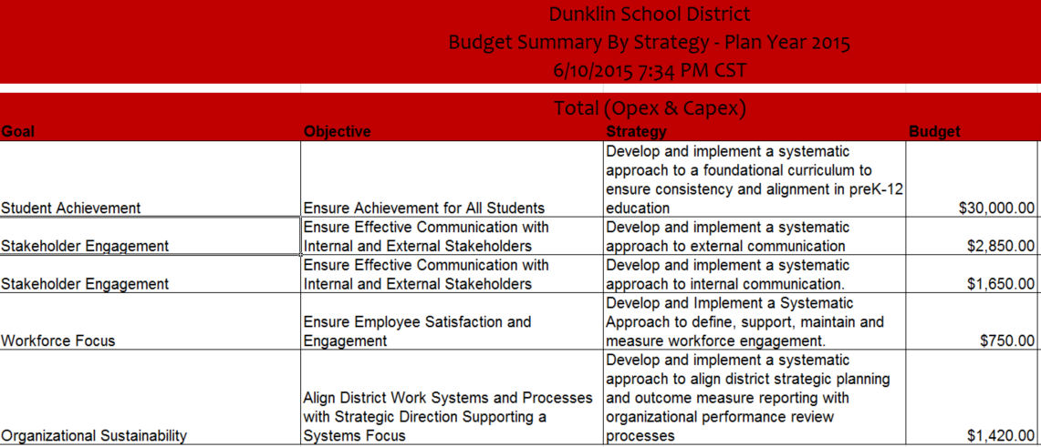

Implementation Process

# Annual Kick-Off

At the beginning of the plan and after each annual update, the approved activities and measures should be communicated to the organization and to the resources responsible for implementing components of the plan. The following activities should be completed:

1. Organizational leadership should identify the dates of the monthly review meetings and establish deliverables for the information to be presented in the meeting which should include implementation plan statuses, dashboard results, and balanced scorecard results. This information should be communicated to the goal team leaders.
2. Goal team leaders should meet together as a team to identify interdependencies of the action plans identified and data collection work that will cross multiple goal teams such as surveys.
3. Goal team leaders should meet with their teams and review the details of the approved plans and establish group norms such as regular meeting times, deliverable due dates for the monthly leadership meetings. Any adjustments in the resource assignments should be made at this time.

# Monthly Review Processes

## 1. Update Action Plans

Action plans should be updated as changes to approaches, milestones, tasks, and resources are identified. Any adjustments to start and end dates should be approved by the leadership team prior to being changed. Any action plans needing leadership attention should be included in the leadership review packet.

## 2. Update Implementation Plans

Implementation plans should be updated prior to the monthly leadership team meeting with the status of the plans and the identification of color status. The parameters for the color statuses in the plans are as follows:

**Blue-**Action plan is ahead of schedule and needs no assistance or attention from leadership.

**Green-**Action plan is within 30 days of committed due dates and needs no assistance or attention from leadership.

**Yellow**-Action plan is between 30 and 45 days overdue and/or the team needs assistance or attention from leadership.

**Red**-Action plan is more than 45 days overdue and/or the team needs urgent attention from leadership.

This information will show in the implementation plan report, which should be included in the leadership review packet.

## 3. Update Strategy Measures

Where available the strategy measures attached to each strategy should be updated. Examples of updates include baseline survey information, completion of the project, and update of results experienced as a result of completion of the strategy. This information will print on the Dashboard Report, which should be included in the leadership review packet.

## 4. Update Scorecard Measures

Where available, the objective measures attached to each objective should be updated. Examples of updates include baseline survey information, comparative source, comparative results, measure target, and measure results. This information will print on the Scorecard Report, which should be included in the leadership review packet.

# Leadership Reports

The following reports should be included in the monthly leadership review packet:

1. **Action Plan Reports**-Where the action plan has been changed substantively by the team and/or where the team is requesting a change to the priority or start/end dates for the plan.
2. **Implementation Plans**-Implementation plans should be provided for review by the leadership team. Only strategies with red or yellow statuses will be reviewed in detail by the leadership team.
3. **Dashboard**-The dashboard should be reviewed when there are changes and/or updates to the strategy measures.
4. **Scorecard**-The scorecard should be reviewed when there are changes and/or updates to the objective measures.
5. **Focus Report**-At this time, this report will have to be manually developed to list the strategies identified as in yellow or red status. This report will be available in the strategic planning system by March of 2014.

# Meeting Agenda

An example meeting agenda for the monthly review meeting could include the following review topics:

1. **Review of Focus Report.** Discussion of the items in red or yellow status. As at-risk strategies are reviewed, leadership team will use the action plan reports and implementation plans to determine the status of the strategies.
2. **Review of Dashboard**-Goal team leaders should review their changes to the strategies they are responsible for.
3. **Review of Scorecard**-Goal team leaders should review the updates to the scorecard. The leadership team should discuss and identify any action required.
4. **Review of Decisions**-The leadership team should review the decisions made in the meeting. Goal team owners should discuss decisions made by the leadership team with their goal teams.

## Dunklin R-V Annual Review Process – (see diagram below)

The annual review process is pictured on the following page. The information identified in steps one and two will be analyzed to determine any changes from the original strategic planning analysis. The goals and objectives will be re-confirmed. The action plans completed in the previous year of the plan and the strategies prioritized for future years will be studied and a new set of strategies will be identified for execution in the new plan year.

The planning and review process is used whether a new five-year plan or an annual update is the focus. The difference will be in the detail of the analysis. Dunklin School District will continue to use the Baldrige process to obtain feedback on performance from outside of the organization and include that feedback in the strategic planning process.

Five Year Strategic Plan

-Mission

-Vision

-Goals

-Objectives

**Long-Term Direction Established**

**Dashboard**

**Provides the monthly review of organizational progress against action plans**

**Tactical View of Progress Against**

**Action Plans Established**

**Review and Realignment of Strategic Plan Annually**

**-Leadership Team**

**-Board of Education**

**-Goal Teams**

**-Employees and Departments**

**Annual Review Process**

**One Year Action Plans**

**Tactical plans established each year**

**Implementation** **Plans**

**Plans used to execute action plans and report status throughout the year**

**Strategic Plan Management Flow**